NEIGHBORHOOD TOOL SHARING HUB
@CREATIVITY THINK (9483175986/7019689991)

ABSTRACT:
Neighborhood Tool Sharing Hub is a web-based platform designed to facilitate community-based sharing of tools and equipment among neighbors, apartments, hostels, and makerspaces. Users can list their tools, browse available items in their vicinity, request to borrow, and manage returns. The system tracks availability, ratings, and borrowing history to foster trust and accountability. Administrators can verify users and addresses, flag suspicious items, resolve disputes, and access analytics for insights into community participation. Built with Django and Django REST Framework on the backend and React with axios and react-table on the frontend, the system offers a secure, transparent, and user-friendly tool-sharing ecosystem..

INTRODUCTION OF THE PROJECT:
Access to specialized tools is often limited, costly, or underutilized in local communities. Traditional borrowing methods involve informal arrangements, lack tracking, and may cause disputes. The Neighborhood Tool Sharing Hub provides a centralized platform to list, borrow, and return tools safely while tracking usage and ratings. By digitizing the borrowing process, the platform promotes resource sharing, accountability, and stronger community interactions. Users and administrators benefit from real-time updates, analytics dashboards, and secure workflows that encourage responsible tool lending..

PROJECT OBJECTIVES:

• Enable users to register and list personal tools for sharing
• Allow browsing and searching for nearby tools available for borrowing
• Support borrowing requests, pickup scheduling, and return confirmation
• Track tool availability, ratings, and borrow/lend history
• Provide reminders for due returns and notifications
• Allow administrators to verify users and addresses
• Flag suspicious or problematic items and resolve disputes
• Generate dashboards and export reports for usage analytics
• Promote community resource sharing and trust

PROBLEM OF THE STATEMENT:
Communities often face challenges in sharing tools efficiently due to informal lending practices, lack of tracking, and absence of accountability. Borrowers may forget to return items or items may get damaged, while lenders lack assurance and recordkeeping. Neighborhood Tool Sharing Hub solves these problems by providing a structured, traceable, and transparent platform for borrowing and lending tools, enabling better community resource management and trust-building..

MOTIVATION OF THE PROJECT:
• To promote local sharing of tools and resources
• To reduce unnecessary purchases by enabling borrowing
• To provide a secure and structured environment for tool exchange
• To maintain borrow/lend history and ratings for accountability
• To minimize disputes and manage resolution effectively
• To provide administrators with actionable analytics and reporting
• To foster stronger community engagement and cooperation
• To ensure a user-friendly and transparent tool-sharing experience

BLOCK DAIGRAM OF PROJECT:

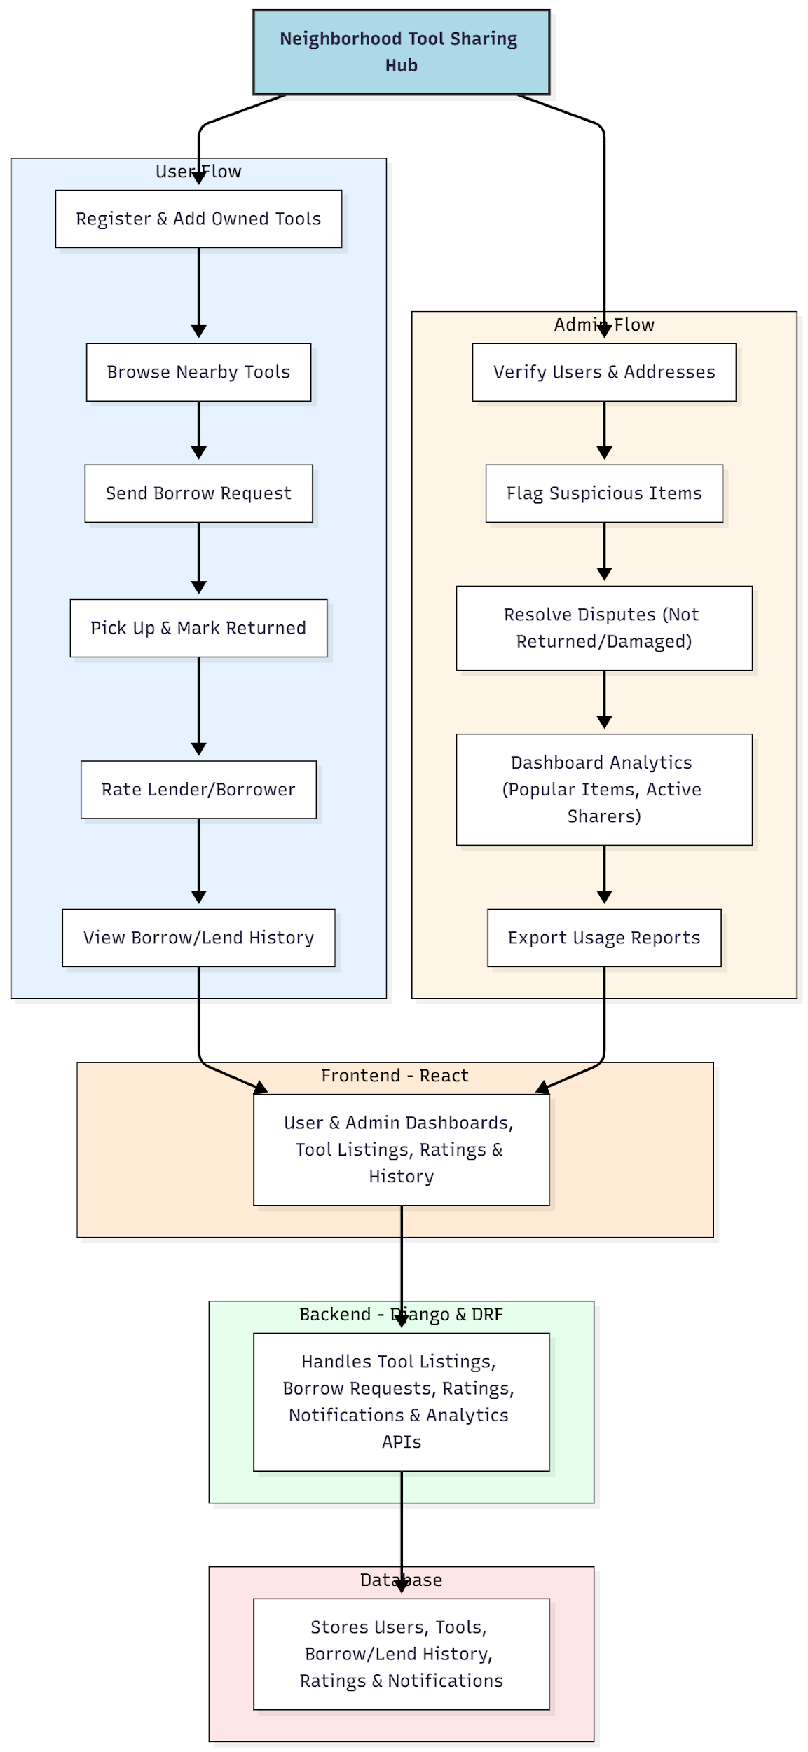

WORKING OF THE PROJECT:
Users start by registering and listing the tools they own. They can browse available tools nearby, send borrow requests, schedule pickup, and mark items as returned after use. Ratings are provided for both lenders and borrowers to build trust. Administrators verify user identities and addresses, monitor flagged items, and manage disputes related to unreturned or damaged tools. The system maintains detailed borrow/lend history and generates analytics dashboards for popular items and active sharers. All interactions are handled via the backend APIs, stored in the database, and presented through an interactive frontend for a seamless community sharing experience..

SOFTWARE REQUIREMENT:
- Backend:
  - Python 3.x
  - Django
  - Django REST Framework
  - SQLite/PostgreSQL
- Frontend:
  - Node.js and npm
  - React.js
  - Axios
- Development Tools:
  - Visual Studio Code
  - Postman (for testing APIs)
  - Git/GitHub (for version control)
- Server/Deployment (Optional):
  - Gunicorn, Nginx, or Heroku/AWS for hosting

ADVANTAGES OF THE PROJECT:

• Promotes community sharing and reduces costs
• Tracks borrow/lend history for accountability
• Ratings and reviews build trust among users
• Admin dashboard helps resolve disputes efficiently
• Real-time updates and notifications improve engagement
• Analytics help identify popular items and active sharers
• Reduces duplication of tools and improves resource utilization
• Encourages responsible borrowing and lending practices

APPLICATIONS OF THE PROJECT:
• Apartment complexes and neighborhoods
• Hostels and student dormitories
• Makerspaces and community workshops
• Local tool-sharing initiatives
• Small community lending programs

REFERENCES:

- Django REST Framework Documentation — Django Software Foundation. Django Documentation. Available: https://docs.djangoproject.com/
- Django REST Framework. DRF Documentation. Available: https://www.django-rest-framework.org/
- React. React Official Documentation. Available: https://reactjs.org/docs/getting-started.html
- Redux. Redux Documentation. Available: https://redux.js.org/introduction/getting-started
- PostgreSQL Global Development Group. PostgreSQL Documentation. Available: https://www.postgresql.org/docs/
- MySQL. MySQL Reference Manual. Available: https://dev.mysql.com/doc/
- Git. Git Documentation. Available: https://git-scm.com/doc
- Node.js. Node.js Documentation. Available: https://nodejs.org/en/docs/
- Axios. Axios Documentation. Available: https://axios-http.com/docs/intro
- Socket.io Documentation – https://socket.io/docs/

